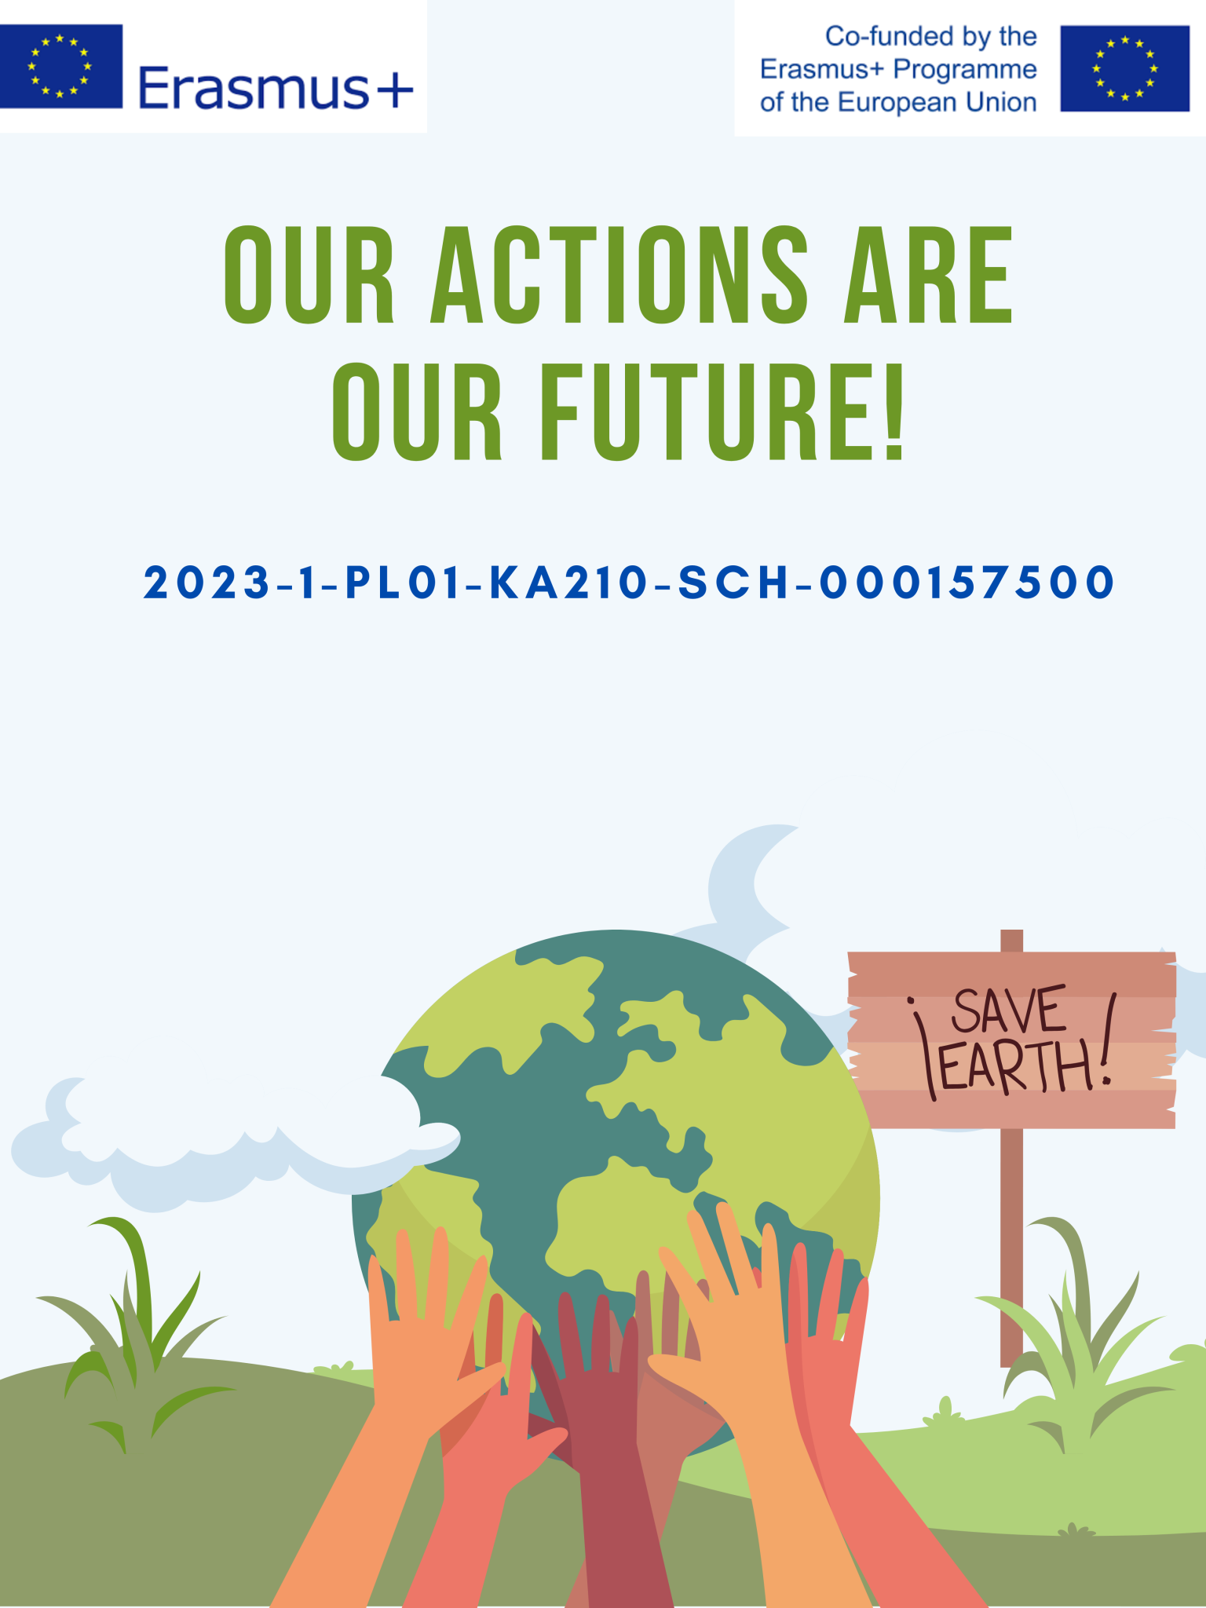

|  |  |  |
| --- | --- | --- |
| **"The world of words in the ecosystem"** | | |
| SECTION A – IDENTIFICATION | | |
| Name of the organization/Institution  implementing practice | | Upesleju primary school |
| Place of implementation | | Classroom |
| **SECTION B – DESCRIPTION** | | |
| Target group / Beneficiaries | | 3rd–4th grade student |
| The main objectives | | Goal is to enrich our language skills and learn to create exciting texts about the environment.   * Vocabulary building: We will learn new words related to ecosystems. * Text creation: We will practice writing engaging descriptions about nature and its diversity. * Teamwork skills: We will work in groups to create interesting texts together. |
| Experts/staff | | Teacher |
| The description of the practice | | **1. Introduction and Warm-up (5 min)**   * Greeting and presentation of the lesson topic * Mind map: *"What is an ecosystem?"* – students name words related to ecosystems * Write the words on the board, grouping them by topic (animals, plants, natural elements   2. **Vocabulary Expansion (10 min)**   * Work with pictures showing different ecosystems * Learning new words:   *Nouns: ecosystem, moss, fern, conifer, deciduous tree, root, bark, lizard, badger, squirrel, woodpecker, dragonfly, spring, stream, cliff*  *Adjectives: wet, green, diverse, interconnected*  *Verbs: grow, feed, adapt, pollination, germination, decomposition*  **Vocabulary Game: “Find the Match!”**  Game Rules:   * Students work in groups of 3–4 * Each group gets a set of cards with words and pictures * The goal is to match the correct word with its picture * One point for each correct match   Objective of the task:   * Strengthen new vocabulary * Practice teamwork and sharing knowledge   **Results**   * Quiz: Quick quiz about the word-picture pairs * Discussion: Talk about the most interesting new words   **3. Practical Work with Text (10 min)**  Sentence Building Workshop:   * Start simple: Create short sentences about nature. *"The squirrel jumps into the tree."* * Add details: Use adverbs and adjectives. *"The brown squirrel quickly jumps into the tall pine tree."* * Connect ideas: Make compound sentences. *"The squirrel jumps into the tree, and the woodpecker pecks the pine trunk."* * Use the board to build sentences together. When a student says a sentence, they choose the next speaker.   **4. Creative Activity: "Describe the Ecosystem!" (10 min)**  Forest Group: Choose a picture of a forest. Write three interesting sentences about the forest. Use at least three new words from the lesson.  Meadow Group: Describe a colorful meadow. Add words about insects and flowers. Create sentences that show the diversity of life.  Water Ecosystem Group: Make a short story about a river or lake. Mention fish, water plants, and birds. Use words that describe water movement.  Descriptive Writing Structure:   * Introduction: Introduce the ecosystem. *"A Latvian forest is home to many animals."* * Description: Describe what you see and hear. *"Sunlight shines through the green spruce needles."* * Connections: Show how things are connected. *"Pinecones feed squirrels and birds."* * Conclusion: Share your feeling or opinion. *"The forest is a magical place that we must protect."*   **5. Conclusion and Reflection (5 min)**   * Presentations: Each group reads their text. Others listen and prepare questions. * Feedback: Share what you liked in each other’s work. Highlight interesting words. Exchange ideas and talk about future topics. *"What else would you like to explore?"*   **Assessment:**   * Student participation and engagement * Use of new vocabulary in speech and writing * Text creation skills * Teamwork in group activities |
| Methodology/Didactic tools | | The lesson uses a **student-centered and interactive approach**, focusing on communication, creativity, and collaboration. Key methodological and didactic elements include:   * **Talking Wall:** A visual and interactive space where students can share ideas, vocabulary, and reflections. It supports language development and collective thinking. * **Presentations:** Students practice public speaking and summarizing their thoughts in a structured way, which enhances confidence and clarity in communication. * **Group Tasks:** Small group activities foster peer learning, critical thinking, and responsibility within a team setting. * **Collaborative Learning:** Emphasis is placed on cooperation, knowledge sharing, and problem-solving together. Students learn from each other and build a shared understanding of the topic.   These methods support **active learning**, help develop **21st-century skills** (communication, collaboration, creativity, and critical thinking), and make the learning process more **engaging and meaningful** for young learners. |
| Additional materials /Equipment needed | | * Pictures * Word cards * Poster paper or large sheets of paper * Pencils and crayons |
| **SECTION C – CONCLUCION** | | |
| Conclusion | * What a great journey!   Together, we learned lots of new words and explored the forest, the meadow, and water habitats. | |
| Recommendation and guidelines | * To strengthen and develop students’ knowledge about the importance of water and its processes in nature. * To continue improving teachers’ ability to organize purposeful educational processes by incorporating a wider variety of methods and techniques. | |