** **

**Nr. 2023-1-PL01-KA210-SCH-000157500**

**‘’Our Actions are Our Future!’’**

**Sustainable cities and communities**

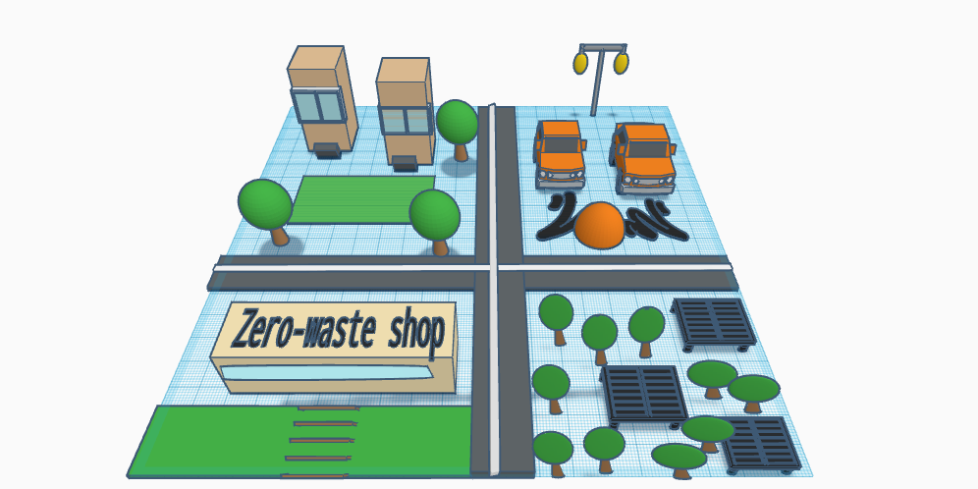

**4.**

**2.**

**1.**

**3.**

Here is the concept illustration of a sustainable city and community, showcasing eco-friendly features.

**3D model number one:** Buildings made with sustainable materials like bamboo and recycled steel. Passive solar design features, such as large windows for natural lighting and proper ventilation.

**3D model number two:** Electric vehicle charging stations throughout the streets.Solar-powered streetlights to reduce energy consumption.

**3D model number three:** Zero-waste shops that encourage reusable packaging. Outdoor recreation areas with benches made from recycled materials.

**3D model number four:** Solar panel farms on rooftops and dedicated areas.

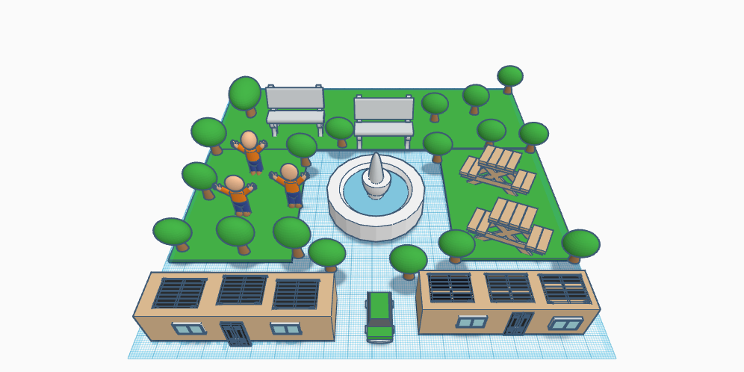

Renewable Energy Sources: solar panels on rooftops. Green spaces, nature trails, and parks are integrated within urban settings, providing residents with areas for recreation and relaxation.