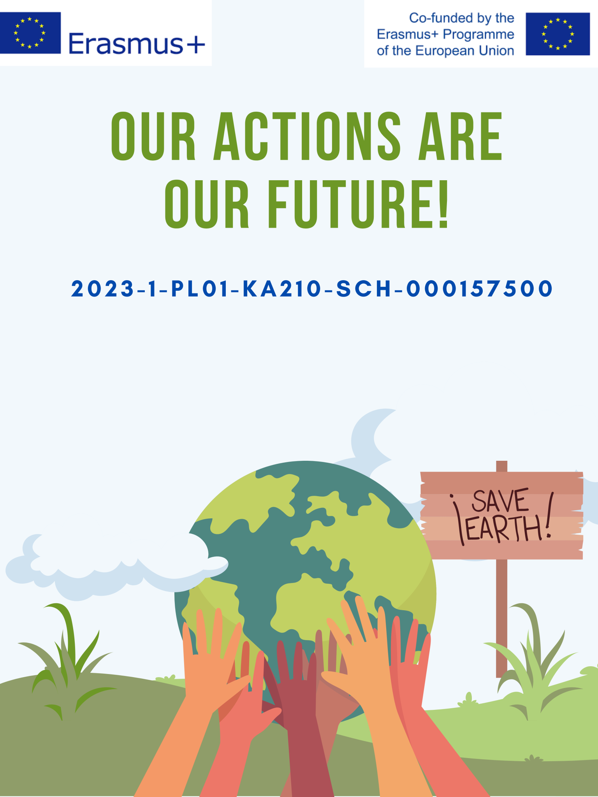

|  |  |  |
| --- | --- | --- |
| **The Water Cycle – Lesson Plan** | | |
| SECTION A – IDENTIFICATION | | |
| Name of the organization/Institution  implementing practice | | Upesleju primary school |
| Place of implementation | | Classroom |
| **SECTION B – DESCRIPTION** | | |
| Target group / Beneficiaries | | 3rd–4th grade students |
| * The main objectives | | * Water is the foundation of life and continuously moves through nature. In this lesson, we will explore the water cycle, a vital process in the ecosystems of our planet. We will look at how water moves from the seas and lakes to the atmosphere, how it returns to the Earth as rain or snow, and how it affects all living nature. We’ll also conduct practical experiments to help us better understand this fascinating natural process: * Introduce students to the water cycle in nature * Develop an understanding of water’s role in ecosystems * Encourage research and observation skills * Promote a responsible attitude toward water resource use |
| Experts/staff  Eksperti/personāls | | Teacher |
| The description of the practice | | 1. Introduction and activating prior knowledge (5 min)  Greeting and presenting the topic  Short discussion with students: “Where do we find water in nature?” (lakes,  seas, rivers, clouds, rain, snow)  Mind map on the board about water in nature  2. Learning new knowledge: The Water Cycle (10 min)  Explanation of the water cycle using pictures or a simple video:  Evaporation (the sun heats water, turning it into vapor)  Condensation (water vapor cools and forms clouds)  Precipitation (rain, snow, hail)  Runoff (water flows in rivers, lakes, seas)  The cycle repeats.  Students complete worksheets by matching pictures with correct terms  3. Practical experiment: “Mini Water Cycle” (10 min)  Students work in pairs or small groups. Each group receives:  A glass of warm water  Plastic wrap  Rubber band  Ice cubes  Task:  Fill a glass with warm water  Cover with plastic wrap and secure with a rubber band  Place ice cubes on top of the wrap  Observe what happens (water condenses and forms droplets)  Students record observations and connect them to the water cycle in nature  4. Research activity: “Exploring Water Properties” (10 min)  Students are divided into 3–4 groups. Each group explores different states or properties of water:  Group 1: Ice melting (observe how ice melts in warmth)  Group 2: Water evaporation (compare evaporation from a wide vs. narrow  container)  Group 3: Saltwater vs. freshwater (compare taste/appearance)  Group 4: Water as a solvent (try dissolving different substances)  Record observations  Brief presentation of results by each group  5. Conclusion and reflection (5 min  Joint review of the water cycle using a large visua  Reflection questions:  “Where can we observe the water cycle in daily life?  “Why is the water cycle important for nature and people?”  Homework: Observe and describe one part of the water cycle in your surroundings (e.g., rain, clouds, fog)  Additional materials or alternative activities  Water cycle song or poem  Cloud observation and classification  Create water-saving ideas for home and school |
| Methodology/Didactic tools | | Interactive discussion and brainstormin  Visual learning  Inquiry-based learning and experimentation  Collaborative learning  Differentiated instruction  Reflective learning  Creative and cross-curricular integration |
| Additional materials /Equipment needed | | Images of the water cycle in nature  Transparent glasses or containers  Water  Plastic wrap  Rubber bands  Worksheets with water cycle images  Salt, water, ice, hot water  Poster paper or large sheets  Pencils, crayons |
| **SECTION C – CONCLUCION** | | |
| Conclusion | Exploring the water cycle is an exciting journey that never ends. Continue observing the presence and changes of water in nature, conduct experiments, and share your discoveries with others. Remember, water is the foundation of life, and understanding its cycle helps us appreciate its value and the need to protect it.  Think about where you can see the water cycle in your daily life and why it is important to nature and people. What actions can you take to save and protect water in your everyday life? | |
| Recommendation and guidelines | * Strengthen and enhance students’ knowledge about the importance of water and its processes in nature. * Continue to improve purposeful pedagogical planning by integrating diverse teaching methods and approaches. | |