Info pack for Latvian meeting
Nr. ERASMUS+ KA210ADU
EMPOWERİNG KİDS WİTH SPECİAL EDUCATİONAL NEEDS İN THE BALTİCS (EKSEN)
2023-2-LT01-KA210-SCH-000173013
JANUARY 2024, 18 OF JANUARY
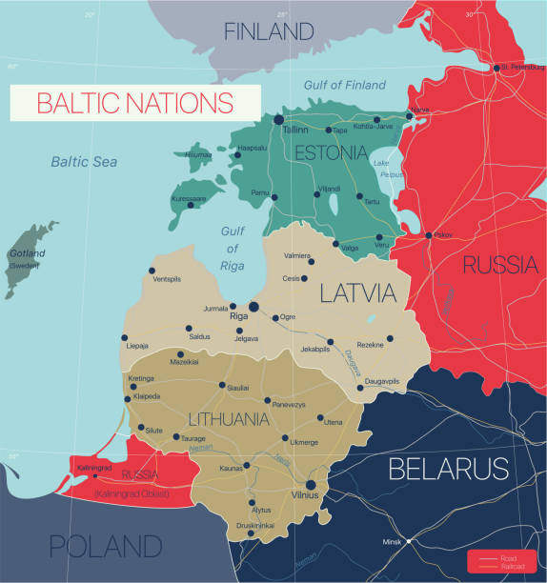
Upesleju sākumskola/Upesleju primary school
Address: Skolas iela 12, Upeslejas, Stopiņu pagasts, Ropažu novads, LV-2118, Latvia
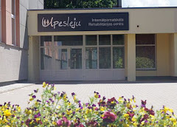
https://www.upeslejuskola.lv/
Coordinator Svetlana Stepane
+37129525122
narinja25@inbox.lv
Office manager Līga Berezovska:
+371 67 956 088

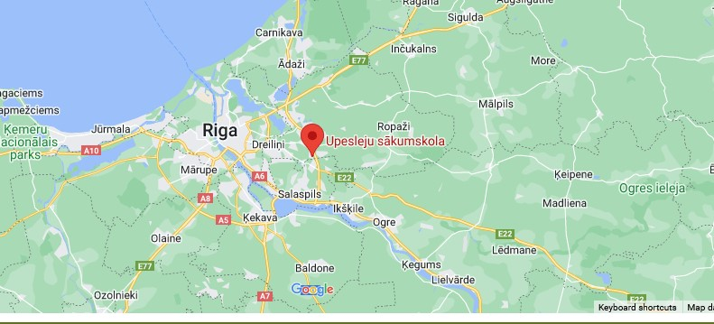

Hotels in Old Riga center
Rixwell Old Riga Palace Hotel-Minsterejas iela 8/10, Рига, LV-1050
Hestia Hotel Draugi-Mārstaļu iela 3, Рига, LV-1050
Old Riga Boutique Hotel "Vecriga"-Gleznotāju iela 12/14, Рига
Wellton Riverside SPA Hotel-11. novembra krastmala 33, Рига
Wellton Riga Hotel & SPA-Vaļņu iela 49, Рига
Wellton Centrum Hotel & SPA-Kalēju iela 33, Рига
And more another hotels, check booking reviews . With good reviews all hotels in Old center is good.
For hotel use OLD CENTER .
But about parking you need ask directly in hotel, because car driving/parking not allowed in Old center, only if hotel have this possibilities. Or you need use city parkings near Old center.

For driving with car to school use WAZE app better.
For public transport:
www.1188.lv
Chooose TRANSPORT, after write from RĪGA to Upeseljas, dates and can see bus with stops.
